Assignment 3

1) echo hello world : Print hello world on the console.

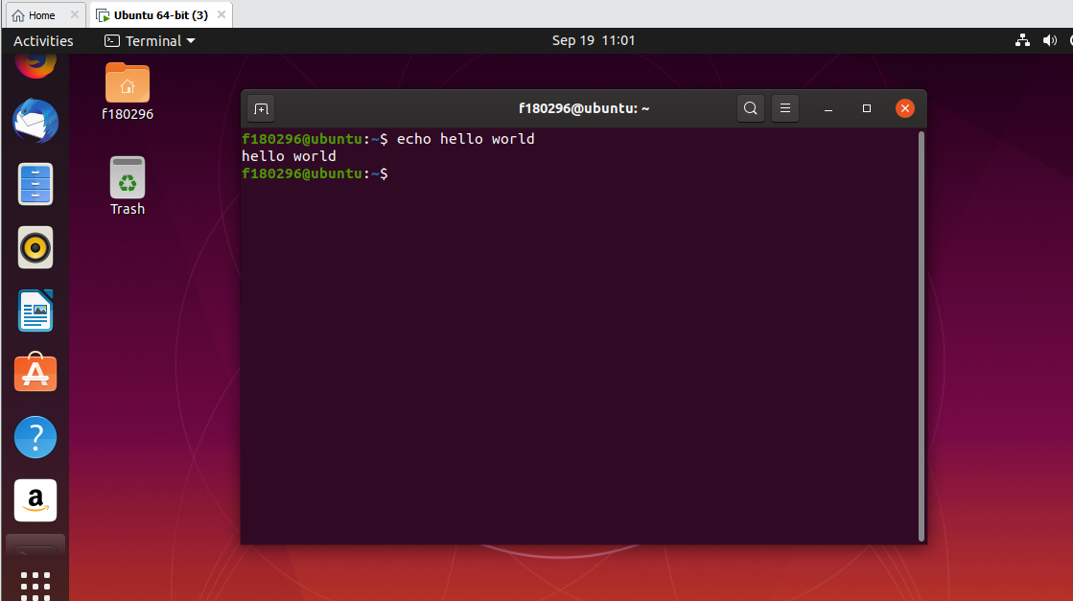

2) ***passwd:*** This command is used to change the password of current user

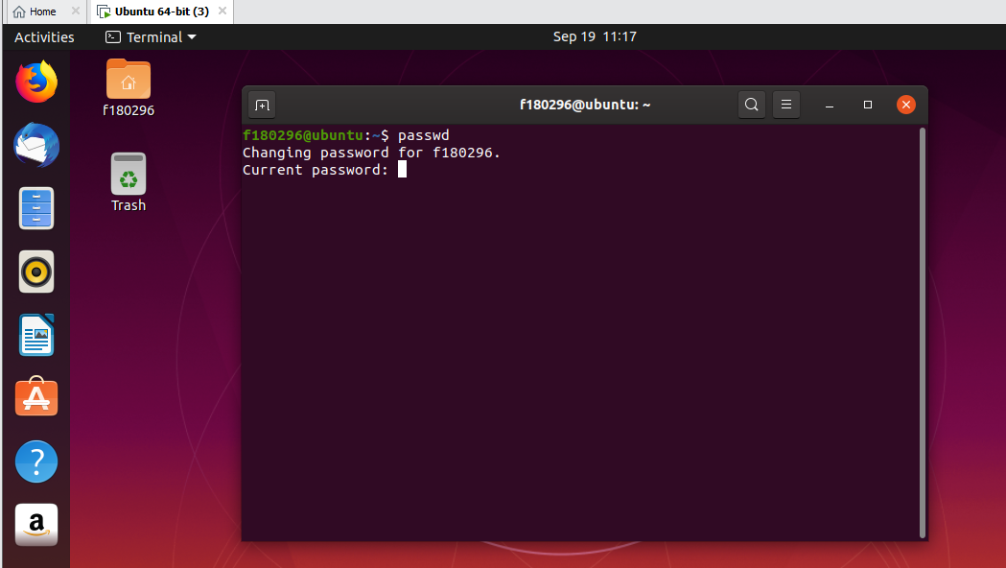

***date:*** Displays current date and time.

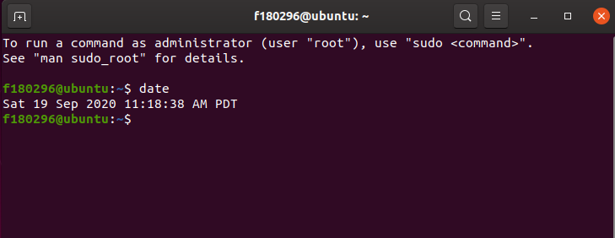

***hostname :***Displays the name of thecurrent computer. It is usually used to identify one on the internet.

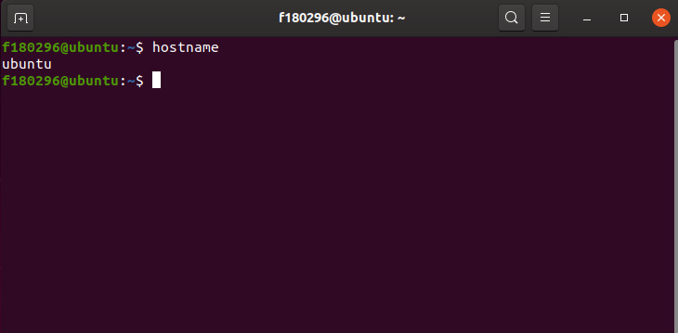

***arch:*** Displays the architecture of computer.

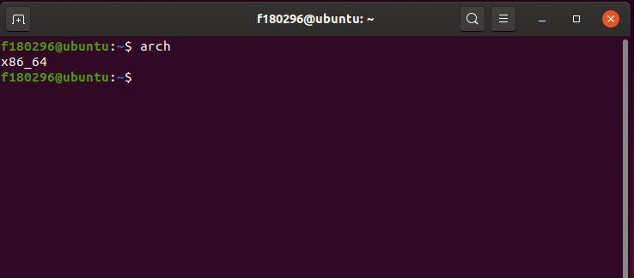

***uname -a:*** Display information about computer including its host name, OS being used and architecture.

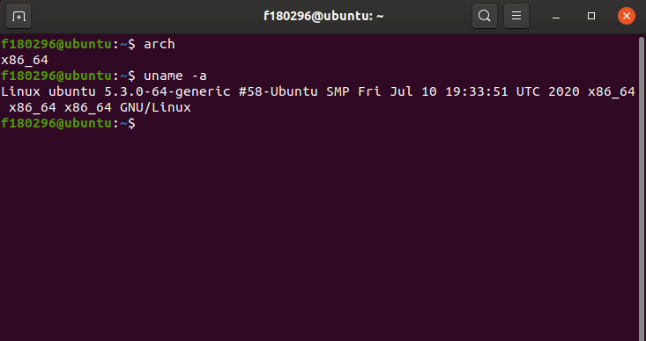

***uptime:*** Display average load on the machine and number of minutes since it’s turned on.

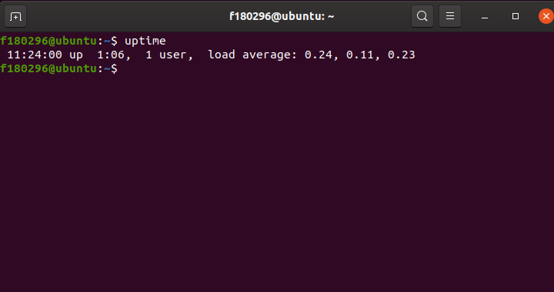

***whoami:*** Display the current username

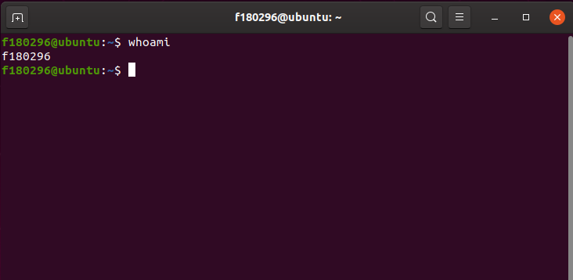

***who:*** Display current logged in users and time of the last boot

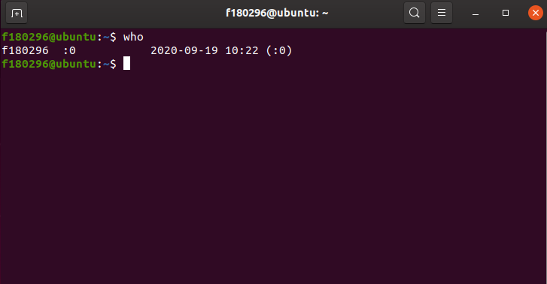

***Id:*** id is a command-line utility that prints the real and effective user and group IDs.

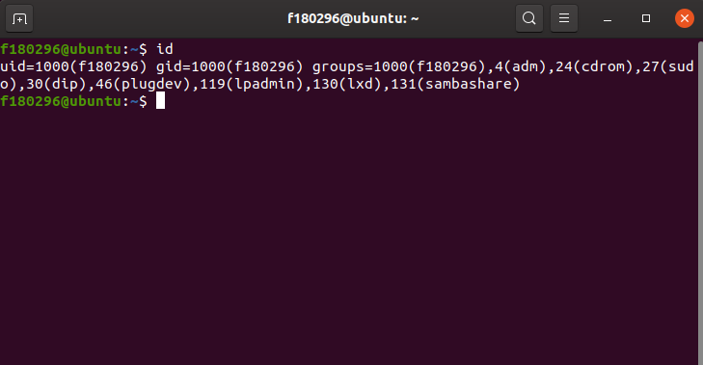

***last:*** Display history of users logging in and out.

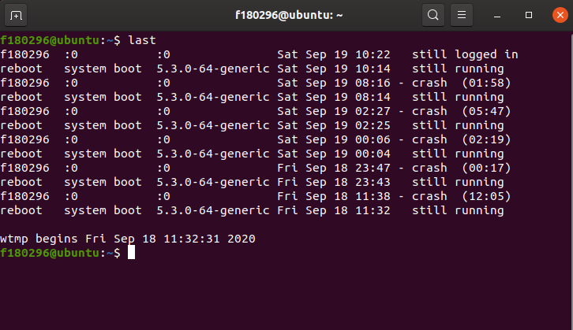

***w:*** Display details about username, login date and few other details. ‘who’ and ‘whoami’ are derived from this command.

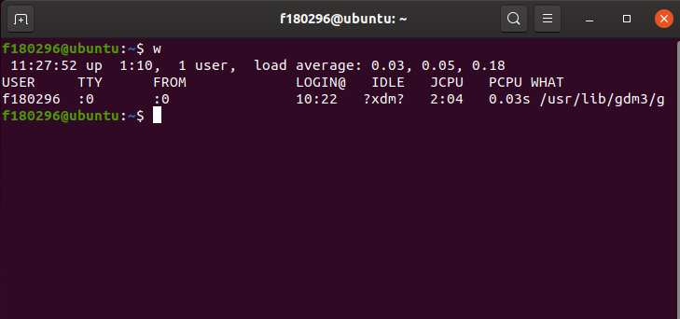

***top:*** Display detailed information about resource usage by applications, users and kernel.

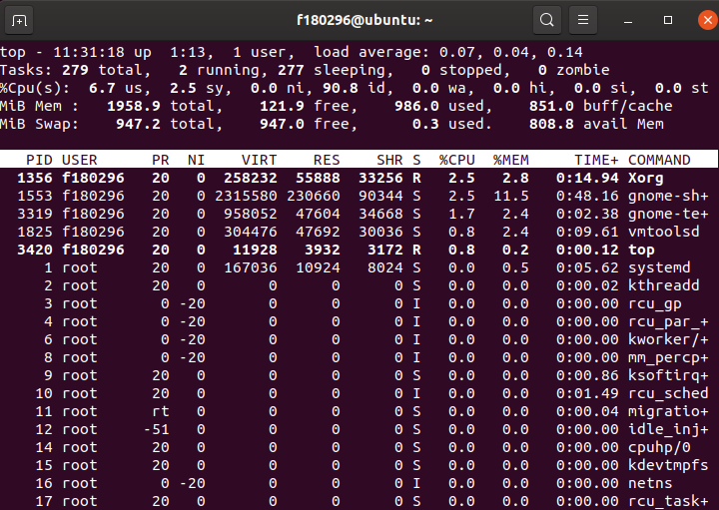

***echo $SHELL:*** Display the directory of an executable file named ‘bash’.

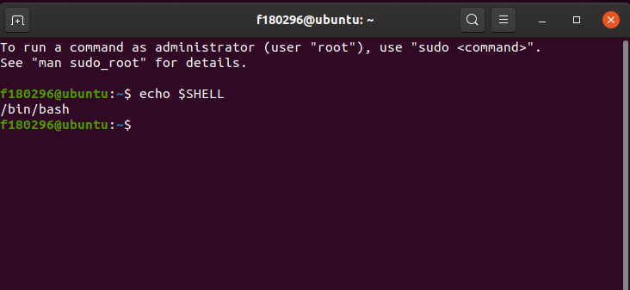

***man ls:*** List information about the FILEs (the current directory by default).

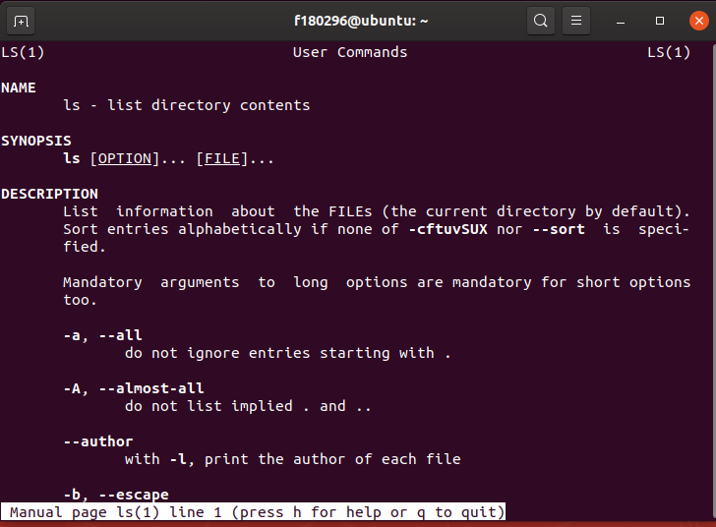

***man who:*** Print information about users who are currently logged in.

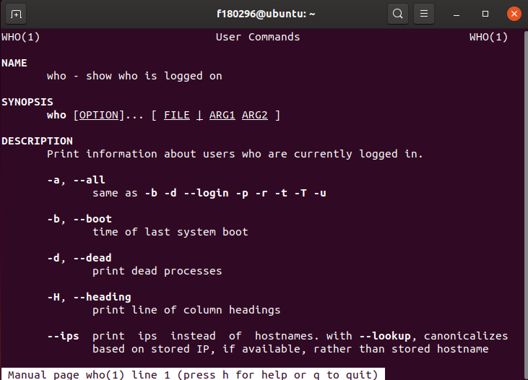

***clear:*** Clears the terminal screen.

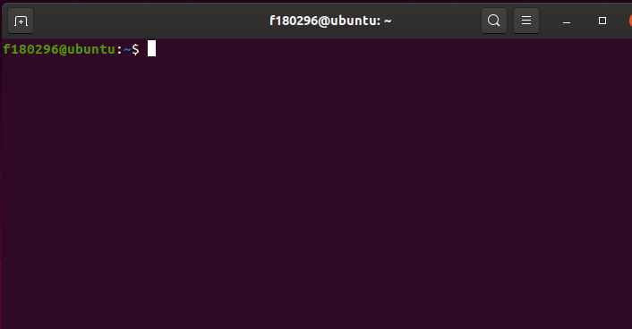

***cal 2000:*** Display the calendar for the whole year of 2000.

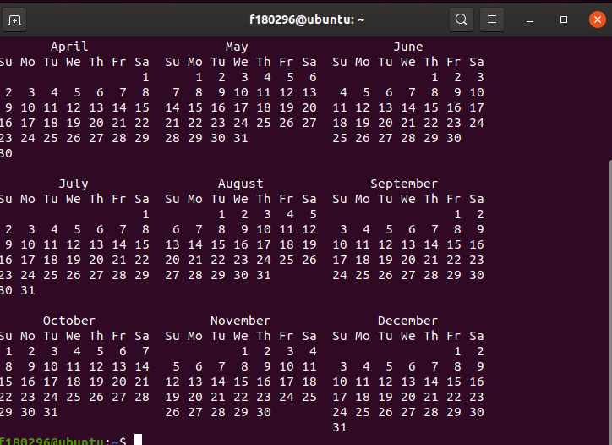

***cal 9 1759:*** Display the calendar for the 9th month of year1759.

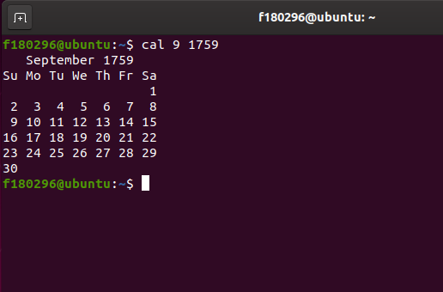

***echo 5+4 | bc –l :*** here we are doing addition of two 2 numbers

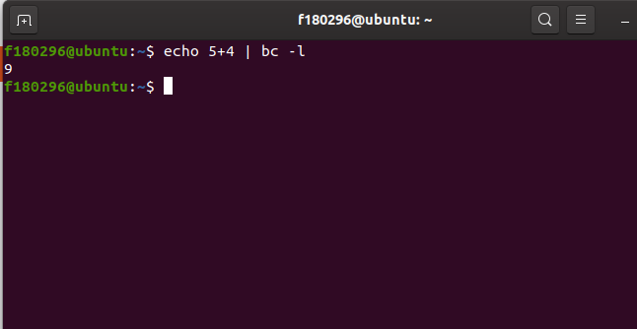

***yes please:***Print ‘please’ indefinitely until CTRL + Cis pressed.

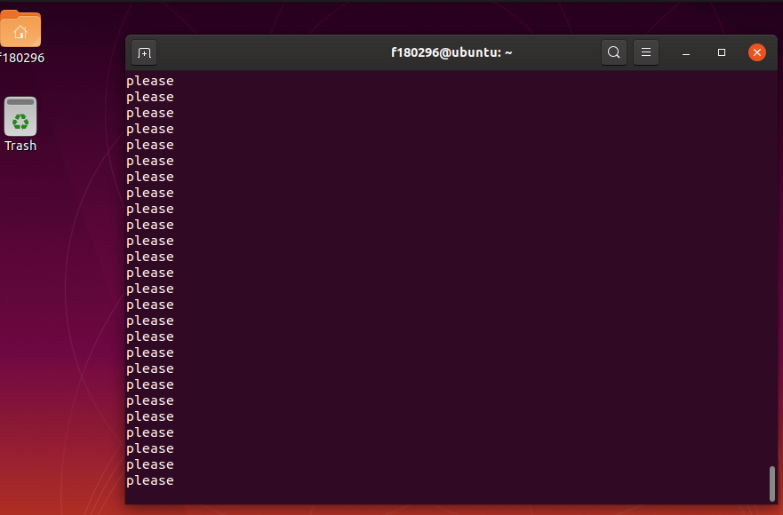

***time sleep 5:***Delay / stop / sleeps any execution or command by 5 seconds.

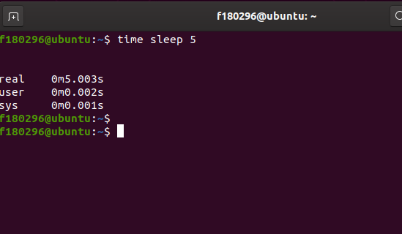

***history:***Display the history of commands executed in the terminal.

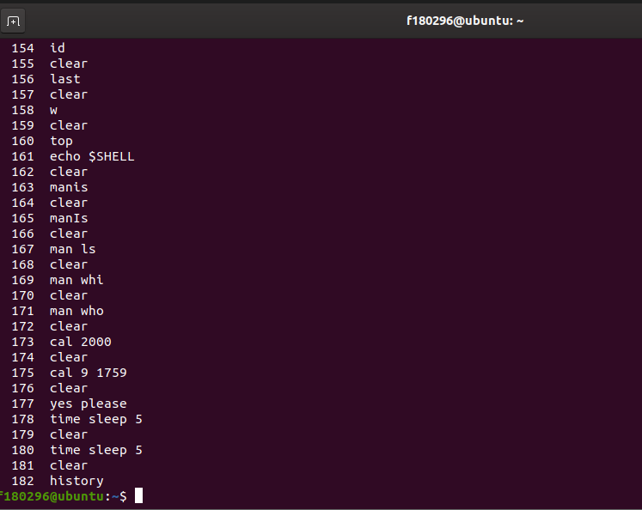

***sudo apt-get install nasm:*** This is Quick Install Instructions of **nasm** on Ubuntu Server.

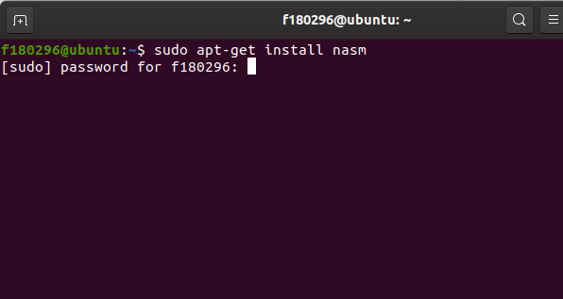

***Problem 2***

**All instruction implemented consecutively!**

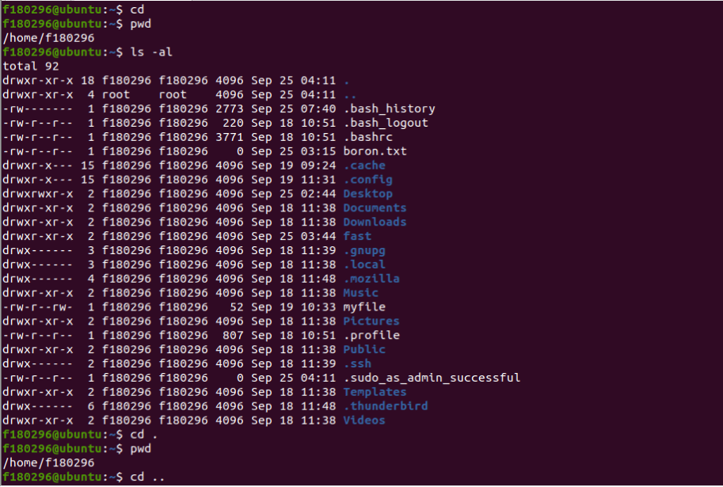

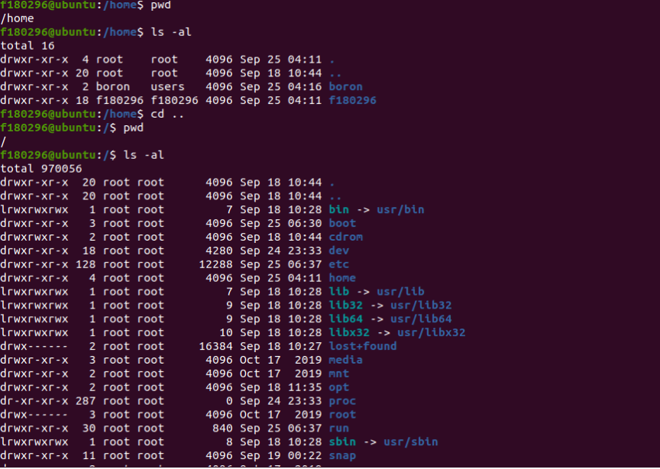

**Here “pwd” lead me to the root directory!**

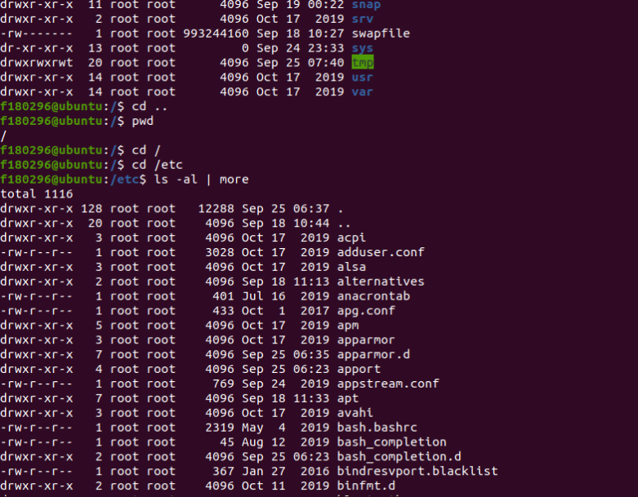

**Again it’s showing that I am in the root directory**

